Federated Learning for ICU Length-of-Stay Prediction: A Comparative Study of FedAvg vs D-PSGD Using MIMIC-IV

Abstract- Predicting intensive care unit (ICU) length-of-stay (LOS) is important for hospital resource planning and patient management. However, healthcare data are typically siloed across institutions due to privacy regulations and governance constraints. Federated learning (FL) enables collaborative model training without requiring raw data sharing. This study compares two decentralized learning approaches—Federated Averaging (FedAvg) and Decentralized Parallel Stochastic Gradient Descent (D-PSGD), also known as gossip learning—for ICU length-of-stay prediction using the MIMIC-IV dataset. Experiments evaluate predictive performance, communication efficiency, and convergence behavior within a simulated multi-hospital private network environment.
- INTRODUCTION
The increasing adoption of electronic health records (EHRs) has created new opportunities to apply machine learning techniques to support clinical decision-making. One important application is predicting intensive care unit (ICU) length of stay (LOS), which helps hospitals improve resource allocation, capacity planning, and patient flow management. Accurate LOS prediction can enhance bed utilization, optimize staffing, and improve overall healthcare efficiency.
Although large clinical datasets such as MIMIC-IV are publicly available, real-world healthcare data are typically distributed across institutions and cannot be centrally aggregated due to privacy regulations, governance policies, and institutional data ownership constraints. These challenges limit the applicability of traditional centralized machine learning approaches in multi-hospital environments.
Federated learning (FL) provides a solution by enabling collaborative model training across institutions without sharing raw patient data. Instead, model parameters are exchanged while the data remain locally stored. The most common FL approach is Federated Averaging (FedAvg), where a central server aggregates updates from participating clients. While effective, this centralized design may introduce communication bottlenecks and single points of failure.
An alternative approach is Decentralized Parallel Stochastic Gradient Descent (D-PSGD), where nodes exchange model updates directly with neighboring peers without relying on a central server. This study compares FedAvg and D-PSGD for ICU LOS prediction in a simulated multi-hospital cloud environment, evaluating prediction accuracy, convergence behavior, and communication efficiency.
- RELATED WORK
Predicting intensive care unit (ICU) length of stay (LOS) is a widely studied problem due to its importance for clinical decision-making, hospital capacity planning, and resource optimization. Early research primarily relied on centralized machine learning models trained on large-scale electronic health record (EHR) datasets such as MIMIC-III and MIMIC-IV. For example, Hasan et al. evaluated multiple regression-based models, including random forests and gradient boosting, for ICU LOS prediction using the MIMIC-III dataset and demonstrated strong predictive performance under centralized data assumptions. Similarly, Hempel et al. proposed a centralized machine learning framework for LOS prediction using MIMIC-IV, incorporating demographic information, early vital signs, and laboratory measurements collected during the first 24 hours of ICU admission. While these studies establish strong predictive baselines, they assume that patient data from multiple institutions can be aggregated in a central repository, which is often infeasible in practice due to privacy regulations, governance policies, and institutional data silos.
To address these challenges, privacy-preserving collaborative learning approaches such as federated learning (FL) have gained increasing attention. Federated learning enables multiple institutions to jointly train machine learning models without sharing raw patient data. Wang et al. introduced a multimodal federated learning framework for ICU LOS prediction that integrates structured and unstructured clinical data while maintaining data locality. Their results demonstrate that federated models can achieve predictive performance comparable to centralized approaches while preserving privacy. However, their framework relies on conventional centralized FL architectures using server-based aggregation and does not explore alternative communication or optimization strategies.
Decentralized federated learning methods have been proposed to remove the dependency on a central aggregation server. Algorithms such as decentralized parallel stochastic gradient descent (D-PSGD) enable peer-to-peer model updates across networked nodes, potentially improving system robustness and fault tolerance. Despite these advantages, empirical evaluations of decentralized FL in realistic healthcare prediction tasks remain limited.
To the best of our knowledge, no prior work has systematically compared centralized federated learning and decentralized gossip-based optimization for ICU LOS prediction using the MIMIC-IV dataset. This study addresses that gap by empirically evaluating FedAvg and D-PSGD under a hospital-partitioned data setting.
- METHODOLOGY
This study investigates privacy-preserving collaborative learning for predicting intensive care unit (ICU) length of stay (LOS) across multiple institutions. The proposed framework evaluates two distributed learning paradigms—Federated Averaging (FedAvg) and Decentralized Parallel Stochastic Gradient Descent (D-PSGD)—under heterogeneous hospital data distributions.
The overall methodology consists of five main stages: dataset preparation, simulated hospital partitioning, local model training, distributed model aggregation, and performance evaluation. The workflow of the proposed framework is illustrated in Figure 1.
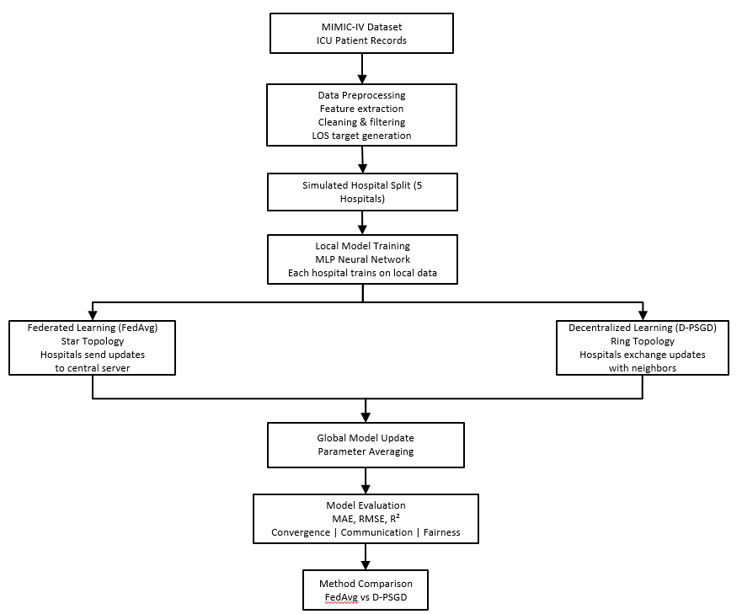
Figure 1: Workflow for Distributed ICU Length-of-Stay Prediction Using FedAvg and D-PSGD
First, ICU patient records are extracted from the MIMIC-IV dataset. Relevant demographic information, physiological measurements, and laboratory values recorded during the first 24 hours of ICU admission are used as input features. Data preprocessing includes filtering invalid records, handling missing values, and generating the target variable representing ICU length of stay.
To simulate a multi-institution environment, the dataset is partitioned into five hospitals based on ICU care unit types. Each hospital therefore represents a clinically distinct patient population, resulting in non-independent and identically distributed (non-IID) data across institutions.
Each hospital independently trains a multilayer perceptron (MLP) model using its local dataset. The model learns to predict ICU length of stay from the extracted clinical features. During distributed training, hospitals periodically exchange model parameters using one of two communication strategies: centralized federated learning or decentralized gossip-based learning.
In the Federated Averaging (FedAvg) configuration, a central server coordinates the training process by aggregating model updates received from participating hospitals. The server computes a weighted average of local model parameters and broadcasts the updated global model to all hospitals in each communication round.
In contrast, the Decentralized Parallel Stochastic Gradient Descent (D-PSGD) configuration removes the need for a central coordinator. Hospitals are connected through a ring communication topology, where each node exchanges model parameters with its neighboring hospitals and performs weighted averaging locally. Through repeated peer-to-peer exchanges, the models gradually converge toward a consensus solution.
Finally, the performance of both approaches is evaluated using standard regression metrics including mean absolute error (MAE), root mean squared error (RMSE), and coefficient of determination (R²). Additional analyses examine convergence behavior, communication overhead, and performance fairness across hospitals.
To evaluate collaborative machine learning across multiple institutions while preserving network isolation, the experimental deployment simulates a distributed healthcare environment in which several hospitals train models without sharing raw patient data. Each hospital operates within an independent cloud network and communicates through a secure overlay network that enables encrypted connectivity between nodes. This design allows the study of both centralized federated learning and decentralized training methods under realistic inter-organizational constraints.
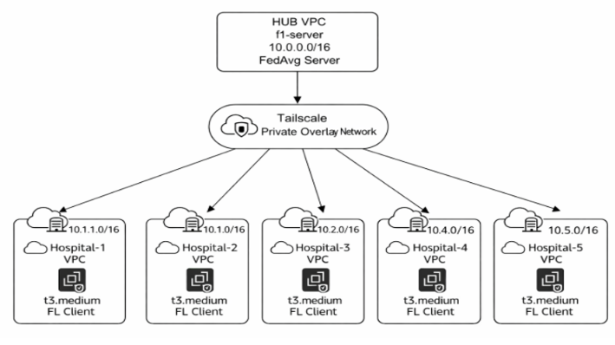
Figure 2: Federated learning Architecture
Figure 2 illustrates the architecture used for centralized federated learning with the Federated Averaging (FedAvg) algorithm. Five hospitals are deployed as independent Virtual Private Clouds (VPCs), each containing a training node implemented as an EC2 t3.medium instance. These nodes act as federated learning clients that train models locally using their respective dataset partitions. A centralized aggregation server is deployed in a separate hub VPC (10.0.0.0/16) and coordinates the training process. During each training round, hospitals compute local model updates and transmit them to the server, which aggregates the parameters to produce a global model. Communication between all nodes is established through a Tailscale private overlay network, enabling encrypted connectivity while maintaining the isolation of the underlying VPC infrastructure.
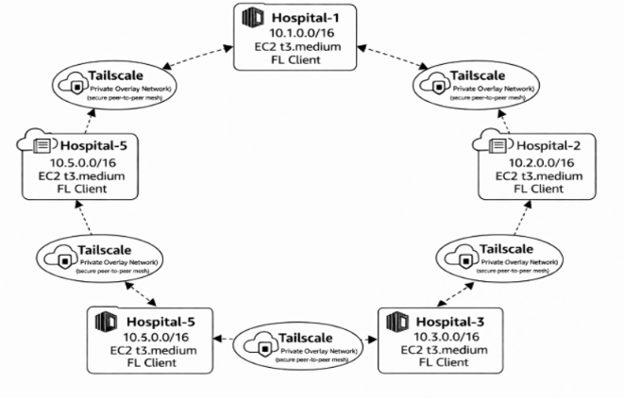
Figure 3: D-PSGC Ring Architecture
Figure 3 shows the decentralized training configuration used for the D-PSGD experiments. In this architecture, the central server is removed, and hospitals communicate directly with one another. Each hospital node exchanges model parameters with its neighbouring nodes in a logical ring topology. Through repeated local updates and peer-to-peer averaging, the distributed network gradually converges to a shared model without centralized coordination. As in the federated setup, the Tailscale overlay network provides secure connectivity across the isolated hospital environments.
These two architectures enable direct comparison between centralized federated learning and fully decentralized training approaches in a controlled multi-institution cloud environment.
- RESULT
This section evaluates the performance of Federated Averaging (FedAvg) and Decentralized Parallel Stochastic Gradient Descent (D-PSGD) on the ICU length-of-stay (LOS) regression task derived from the MIMIC-IV dataset. Performance is measured using validation mean absolute error (MAE) in days. Unless otherwise stated, experiments are conducted with E = 3 local epochs per communication round.
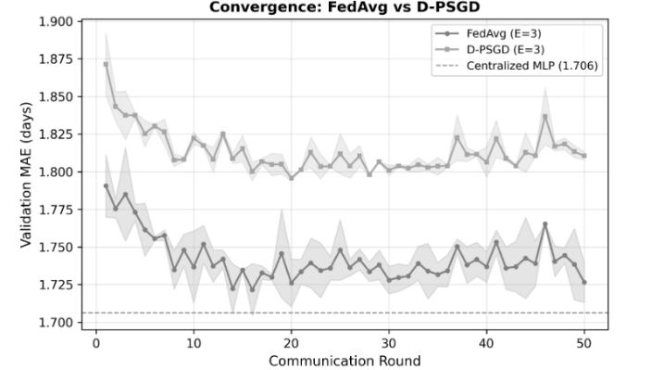
Figure 4: Convergence of FedAvg and D-PSGD
Figure 4 illustrates the convergence of FedAvg and D-PSGD over 50 communication rounds, with a centrally trained multilayer perceptron (MLP) shown as an upper-bound reference. Both distributed methods exhibit rapid error reduction during the initial rounds, followed by gradual stabilization. However, FedAvg consistently converges to a lower validation MAE than D-PSGD.
FedAvg stabilizes at approximately 1.73–1.75 days, whereas D-PSGD converges to a higher error range of 1.80–1.83 days. The centralized model achieves the lowest error (1.706 days), as expected, due to direct access to the pooled dataset without partitioning or communication constraints. Notably, FedAvg approaches the centralized baseline more closely than D-PSGD, indicating more effective aggregation of heterogeneous hospital updates.
The shaded confidence regions further reveal that FedAvg exhibits lower variance and smoother convergence compared to D-PSGD. In contrast, D-PSGD displays persistent oscillations even after apparent convergence, suggesting less stable optimization dynamics. This behaviour is consistent with decentralized gossip-based optimization, where consensus is achieved approximately rather than exactly at each round.
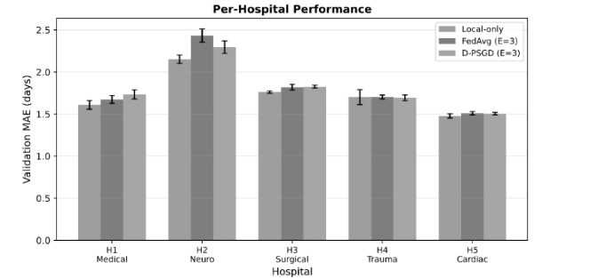
Figure 5: Per-Hospital performance
Figure 5 reports validation MAE for each hospital partition under three training regimes: local-only, FedAvg, and D-PSGD. Results demonstrate that no single training paradigm uniformly dominates across all hospitals, highlighting the impact of data heterogeneity.
For smaller or more specialized hospitals (e.g., H2 – Neurology), distributed training yields higher error than local-only training, likely due to distributional mismatch between local data and the global objective. Conversely, for more representative or data-rich hospitals (e.g., H4 – Trauma and H5 – Cardiac), FedAvg provides modest improvements or maintains parity with local-only baselines.
Across hospitals, FedAvg generally outperforms D-PSGD, although the margin varies. This suggests that centralized aggregation in FedAvg better balances inter-hospital heterogeneity, whereas peer-to-peer averaging in D-PSGD can amplify local biases when data distributions differ substantially.
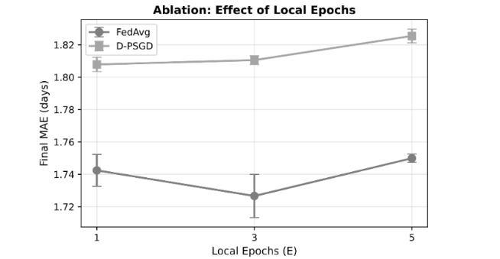
Figure 6: Ablation: Effect on local Epoch
Figure 6 presents an ablation study on the number of local epochs per round (E ∈ {1, 3, 5}). For FedAvg, performance improves when increasing E from 1 to 3, reaching its lowest MAE at E = 3, but degrades slightly at E = 5. This indicates a trade-off between local optimization and global consistency: excessive local training leads to client drift, reducing the effectiveness of global aggregation.
In contrast, D-PSGD shows monotonic degradation as E increases. Since D-PSGD relies on decentralized consensus rather than centralized averaging, increasing local epochs exacerbates divergence between peers, resulting in poorer convergence. These findings indicate that D-PSGD is more sensitive to local over-optimization than FedAvg in heterogeneous healthcare settings.
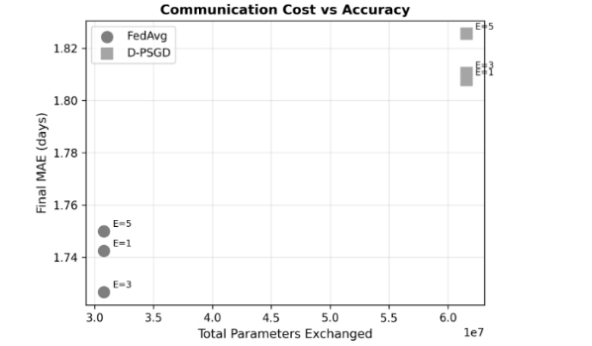
Figure 7: Communication cost vs accuracy
Figure 7 compares final validation MAE against the total number of model parameters exchanged during training. FedAvg achieves better accuracy with substantially lower communication cost, particularly at E = 3, which emerges as the Pareto-optimal configuration. Increasing E reduces the number of communication rounds but does not improve final accuracy beyond this point.
D-PSGD incurs significantly higher communication overhead due to repeated peer-to-peer exchanges yet still converges to a worse solution. This highlights a key practical limitation of decentralized optimization in bandwidth-constrained or cost-sensitive environments, such as multi-institution healthcare deployments.
Overall, the results demonstrate that FedAvg provides superior convergence speed, stability, and accuracy compared to D-PSGD for ICU LOS prediction under realistic hospital-partitioned data. While D-PSGD removes the need for a central coordinator, its sensitivity to data heterogeneity and higher communication cost limits its effectiveness in this setting. FedAvg, particularly with a moderate number of local epochs, offers a more favorable trade-off between performance and communication efficiency.
- DISCUSSION
The experimental results demonstrate that communication topology plays a significant role in collaborative model training across heterogeneous healthcare datasets. Centralized federated learning using FedAvg achieves consistently lower prediction error and more stable convergence compared to decentralized D-PSGD. The centralized aggregation mechanism enables the global model to integrate information from all hospitals at each round, facilitating faster propagation of knowledge across the network.
In contrast, the decentralized gossip-based approach requires information to propagate gradually across neighbouring nodes. This results in slower convergence and greater variability in model updates, particularly when data distributions differ substantially across hospitals.
Nevertheless, decentralized learning provides important architectural advantages. By removing the central server, D-PSGD improves fault tolerance and eliminates reliance on a trusted aggregator. These characteristics may be desirable in large-scale or highly distributed healthcare networks where centralized coordination is difficult to maintain.
The per-hospital analysis further reveals that data heterogeneity affects collaborative learning outcomes. Hospitals with larger datasets or more representative patient populations tend to benefit more from global aggregation, whereas smaller specialized hospitals may experience limited gains. Understanding these fairness dynamics is important for designing equitable collaborative learning systems in healthcare.
- LIMITATION OF STUDY
Despite providing a systematic comparison of centralized federated learning (FedAvg) and decentralized gossip-based optimization (D-PSGD) for ICU length-of-stay prediction, several limitations remain. First, the experiments rely on the MIMIC-IV dataset derived from a single hospital system. Although the data were partitioned to simulate five hospitals with heterogeneous populations, these partitions may not fully represent the diversity found across independent healthcare institutions. Second, the study uses a simulated cloud-based federated environment rather than a real cross-hospital deployment. While the architecture models network isolation using separate virtual private clouds and secure overlay networking, it does not capture real-world constraints such as varying network bandwidth, institutional policies, and hardware differences. Third, the model architecture is limited to a multilayer perceptron, and more advanced models may behave differently in distributed settings. Finally, the study evaluates only two training strategies and does not incorporate advanced privacy mechanisms such as differential privacy or secure aggregation.
- CONCLUSION
This study presents the first empirical comparison between centralized federated learning and decentralized gossip-based optimization for ICU length-of-stay prediction using the MIMIC-IV dataset. By simulating a five-hospital federation with clinically meaningful non-IID data partitions, we analyse how communication topology influences model convergence, predictive accuracy, and institutional fairness.
Our results show that Federated Averaging achieves better predictive performance and more stable convergence, while decentralized D-PSGD offers improved system robustness by removing the central coordinator. These findings highlight a fundamental trade-off between predictive accuracy and architectural decentralization in privacy-preserving healthcare machine learning.
Future work will explore larger federated networks, alternative decentralized communication topologies, and the integration of differential privacy mechanisms to further enhance data security and model robustness.
REFERENCES
[1] L. Hempel, S. Sadeghi, and T. Kirsten, “Prediction of intensive care unit length of stay in the MIMIC-IV dataset,” Applied Sciences, vol. 13, no. 12, p. 6930, 2023, doi: 10.3390/app13126930.
[2] M. N. Hasan and S. Poudel, “Prediction of length-of-stay on MIMIC-III database using machine learning,” 2023.
[3] A. E. W. Johnson et al., “MIMIC-IV (version 2.0): A freely accessible electronic health record dataset,” Scientific Data, vol. 10, no. 1, 2023, doi: 10.1038/s41597-022-01899-x.
[4] H. B. McMahan, E. Moore, D. Ramage, S. Hampson, and B. A. y Arcas, “Communication-efficient learning of deep networks from decentralized data,” in Proc. 20th Int. Conf. Artificial Intelligence and Statistics (AISTATS), 2017, pp. 1273–1282.
[5] X. Lian, C. Zhang, H. Zhang, C. Hsieh, W. Zhang, and J. Liu, “Can decentralized algorithms outperform centralized algorithms? A case study for decentralized parallel stochastic gradient descent,” in Proc. Advances in Neural Information Processing Systems (NeurIPS), 2017.
[6] Q. Yang, Y. Liu, T. Chen, and Y. Tong, “Federated machine learning: Concept and applications,” ACM Transactions on Intelligent Systems and Technology, vol. 10, no. 2, pp. 1–19, 2019.
[7] T. Li, A. K. Sahu, A. Talwalkar, and V. Smith, “Federated learning: Challenges, methods, and future directions,” IEEE Signal Processing Magazine, vol. 37, no. 3, pp. 50–60, 2020.
[8] T. Wang, Y. Guo, and K.-K. R. Choo, “Enabling privacy-preserving prediction for length of stay in ICU: A multimodal federated learning approach,” in Proc. European Conf. Information Systems (ECIS), 2023.
[9] Z. Saidi, O. Akhrif, and Y. El Idrissi, “Centralized versus decentralized federated learning architectures: Design trade-offs, security, and performance in healthcare applications,” in Studies in Computational Intelligence. Springer, 2026.
[10] B. Kairouz et al., “Advances and open problems in federated learning,” Foundations and Trends in Machine Learning, vol. 14, no. 1–2, pp. 1–210, 2021.

